Automated Tumor Detection and Classification in MRI using Convolutional Neural Networks and Image Processing Techniques

## Problem Statement

Manual detection, localization, and classification of tumors in medical images are time-consuming and require specialized expertise. This project aims to automate these processes to assist radiologists in accurately identifying, locating, and classifying tumors in MRI improving diagnostic speed and reliability.

## Description / Requirements

The project will involve developing a deep learning model (CNN) to detect, localize, and classify tumors in MRI. The project will include the following stages:

**1. Data Collection and Preprocessing:**

* Collect a labeled dataset of MRI images with annotations for tumor regions and classifications. Prepare the dataset by resizing, normalizing, and augmenting images to improve model robustness.

**2. Image Processing and Segmentation:**

* **Segmentation Techniques:** Before feeding the images to the CNN, apply image processing techniques to enhance tumor region detection.
* **Tumor Localization Using Segmentation Models:** Implement a segmentation model, such as U-Net or Mask R-CNN, to identify the exact location of the tumor in each scan.

**3. CNN Model for Detection and Classification:**

* Design and implement a CNN architecture suitable for medical image classification to determine if a tumor is present. Classify the tumor type based on its features.

**4. Training and Optimization:**

* + Train the model using the processed and segmented images. Use data augmentation, batch normalization, and transfer learning to enhance accuracy.

**5. Evaluation:**

* + Use metrics such as accuracy, F1 score to assess the model’s performance. The model’s tumor localization accuracy will be evaluated through visual and quantitative assessments.

## Project Goals

• Detect the presence of tumors in MRI.  
• Locate and segment the tumor region to highlight its boundaries.  
• Classify the tumor type based on extracted features.  
• Provide visualizations of segmented tumors to aid medical professionals in diagnosis.

## Deliverables

1. **Preprocessed and Segmented Dataset:** Labeled and preprocessed MRI images with segmented tumor regions.  
2. **CNN Model and Segmentation Codebase:** Implementation of the CNN and segmentation models with configuration files for reproducibility.  
3. **Trained Models:** The final trained models for both tumor detection and segmentation.  
4. **Evaluation Report:** Documentation detailing the performance metrics, with visual examples of successful and unsuccessful detections and segmentations.

## Tools/Libraries

• Programming Language: Python  
• Libraries: TensorFlow/Keras or PyTorch for deep learning, OpenCV for image processing, scikit-image for segmentation techniques, Matplotlib for visualizations.  
• IDE: Google Colab

## Project Timeline

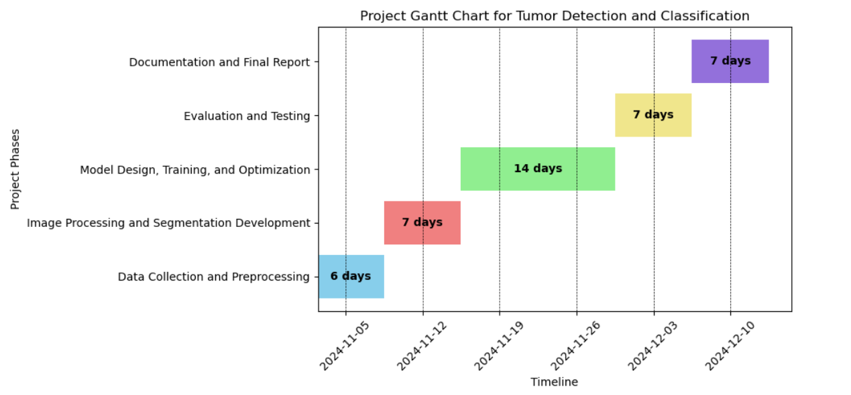s